# Tercera

# Android Estudio V3.0.17/Flutter

Objetivo:

F.Creación: 6-4-2018

Programa:[Tercera](https://flutter.io/tutorials/layout/#step-0)

Fuente:

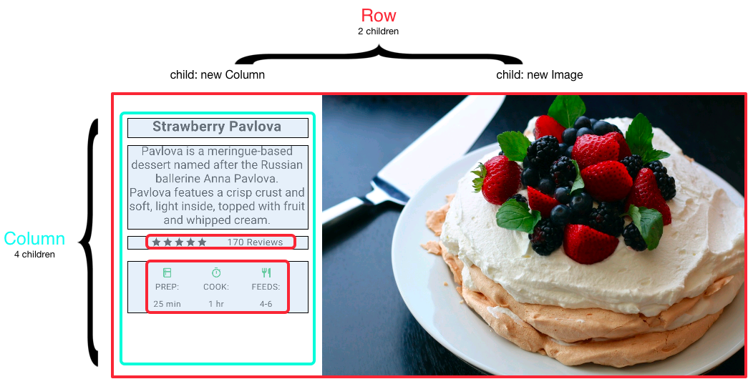

Lamentablemente el ejemplo esta adaptado para un tablet, yo lo adapte para un celular



Li primero que hay notar que la primera fila tiene dos columnas ya de texto y otra de fotografía.

**void** main() {  
 *//debugPaintSizeEnabled = true;* runApp(**new** MyApp());  
}  
  
**class** MyApp **extends** StatelessWidget {  
 @override  
 Widget build(BuildContext context) {  
 **return new** MaterialApp(  
 title: **'Ejercicios de Flutter'**,  
 theme: **new** ThemeData(  
 primarySwatch: Colors.*blue*,  
 ),  
 home: **new** MyHomePage(title: **'PiolaModel:Lucía'**),  
 );  
 }  
}  
  
**class** MyHomePage **extends** StatefulWidget {  
 MyHomePage({Key key, **this**.**title**}) : **super**(key: key);  
  
 **final** String **title**;  
  
 @override  
 _MyHomePageState createState() => **new** _MyHomePageState();  
}  
  
**class** _MyHomePageState **extends** State<MyHomePage> {

*

@override  
 Widget build(BuildContext context) {  
 **return new** Scaffold(  
 appBar: **new** AppBar(  
 title: **new** Text(**widget**.**title**),  
 ),  
 body: **new** Center(  
 child: **new** Container(  
 *margin: new EdgeInsets.fromLTRB(0.0, 3.0, 0.0, 3.0),* height: 500.0,  
 child: **new** Card(  
 child: **new** Row(  
 crossAxisAlignment: CrossAxisAlignment.**start**,  
 children: [  
 **new** Container(  
 width: 160.0,  
 child: **izquierda**,  
 ),  
 **derecha**,  
 ],  
 ),  
 ),  
 ),  
 ),  
 );  
 }  
}

Card🡪 Una tarjeta de diseño de materiales. Una tarjeta tiene esquinas ligeramente redondeadas y una sombra.

Una tarjeta es una hoja de material utilizada para representar cierta información relacionada, por ejemplo, un álbum, una ubicación geográfica, una comida, detalles de contacto, etc.

**var** miCard= **new** Card(  
 child: **new** Column(  
 mainAxisSize: MainAxisSize.**min**,  
 children: <Widget>[  
 **const** ListTile(  
 leading: **const** Icon(Icons.*album*),  
 title: **const** Text(**'The Enchanted Nightingale'**),  
 subtitle: **const** Text(**'Music by Julie Gable. Lyrics by Sidney Stein.'**),  
 ),  
 **new** ButtonTheme.bar( *// make buttons use the appropriate styles for cards* child: **new** ButtonBar(  
 children: <Widget>[  
 **new** FlatButton(  
 child: **const** Text(**'BUY TICKETS'**),  
 onPressed: () { */* ... */* },  
 ),  
 **new** FlatButton(  
 child: **const** Text(**'LISTEN'**),  
 onPressed: () { */* ... */* },  
 ),  
 ],  
 ),  
 ),  
 ],  
 ),  
);

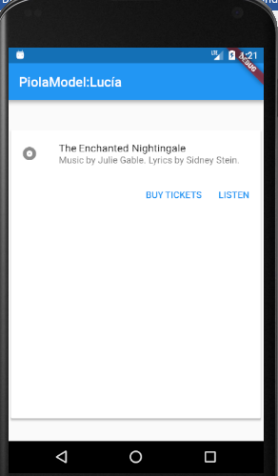el height de 500 es mas o menos el largo del celular para que se vea razonable la chica.

La izquierda esta compuesta de cinco partes

Container **izquierda** = **new** Container(  
 padding: **new** EdgeInsets.fromLTRB(2.0, 2.0, 2.0, 2.0),  
 child: **new** Column(  
 children: [  
 *titMedida*(**"Medidas"**),  
 *descripcion*(),  
 *estrellas*,  
 *buttonSection*,  
 *terna*,  
 ],  
 ),  
);

Las estrella esta hecha a mano,son 5 iconos.La botonera esta adaptada de “1.9 segunda”

La terna es una descomposicion en columnas.

**class** MyApp **extends** StatelessWidget {  
 @override  
 Widget build(BuildContext context) {  
 **return new** MaterialApp(  
 title: **'Ejercicios de Flutter'**,  
 theme: **new** ThemeData(  
 primarySwatch: Colors.*blue*,  
 ),  
 home: **new** MyHomePage(title: **'PiolaModel:Lucía'**),  
 );  
 }  
}  
  
**class** MyHomePage **extends** StatefulWidget {  
 MyHomePage({Key key, **this**.**title**}) : **super**(key: key);  
  
 **final** String **title**;  
  
 @override  
 _MyHomePageState createState() => **new** _MyHomePageState();  
}  
  
**class** _MyHomePageState **extends** State<MyHomePage> {  
 **var derecha** = **new** Image.asset(  
 **'imagenes/Lucia01.jpg'**,  
 width: 200.0,  
 height: 480.0,  
 fit: BoxFit.**cover**,  
 );  
  
 **static** *titMedida*(String titulo) {  
 **return new** Container(  
 padding: **new** EdgeInsets.all(2.0),  
 child: **new** Text(  
 titulo,  
 style: **new** TextStyle(  
 fontWeight: FontWeight.*w800*,  
 letterSpacing: 0.5,  
 fontSize: 18.0,  
 fontFamily: **"Roboto"**,  
 ),  
 ),  
 );  
 }  
  
 **static** Column *buildButtonColumn*(IconData icon, String label) {  
 Color color= **const** Color(0xFF42A5F5);  
 **return new** Column(  
 mainAxisSize: MainAxisSize.**min**,  
 mainAxisAlignment: MainAxisAlignment.**center**,  
 children: [  
 **new** Icon(icon, color: color),  
 **new** Container(  
 margin: **const** EdgeInsets.only(top: 8.0),  
 child: **new** Text(  
 label,  
 style: **new** TextStyle(  
 fontSize: 12.0,  
 fontWeight: FontWeight.*w400*,  
 color: color,  
 ),  
 ),  
 ),  
 ],  
 );  
 }  
  
**static** Widget *buttonSection* = **new** Container(  
 child: **new** Row(  
 mainAxisAlignment: MainAxisAlignment.**spaceEvenly**,  
 children: [  
 *buildButtonColumn*(Icons.*call*, **'LLamar'**),  
 *buildButtonColumn*(Icons.*mail*, **'Mail'**),  
 ],  
 ),  
 );  
  
 **static** *descripcion*() {  
 **return new** Text(  
 **'''  
Estatura. 1.67  
Peso 67  
Medidas 98/65/100  
tez . blanca  
pelo..Castaño   
Edad 30  
'''**,  
 textAlign: TextAlign.**left**,  
 style: **new** TextStyle(  
 fontFamily: **'Courier'**,  
 fontSize: 15.0,  
 ),  
 );  
 }  
  
  
  
 **static var** *estrellas* = **new** Container(  
 padding: **new** EdgeInsets.all(2.0),  
 child: **new** Row(  
 mainAxisAlignment: MainAxisAlignment.**spaceEvenly**,  
 children: [  
 **new** Row(  
 mainAxisSize: MainAxisSize.**min**,  
 children: [  
 **new** Icon(Icons.*star*, color: Colors.*blue*),  
 **new** Icon(Icons.*star*, color: Colors.*blue*),  
 **new** Icon(Icons.*star*, color: Colors.*blue*),  
 **new** Icon(Icons.*star*, color: Colors.*lightBlue*),  
 **new** Icon(Icons.*star*, color: Colors.*lightBlue*),  
 ],  
 ),  
 ],  
 ),  
 );  
  
 **static var** *descTextStyle* = **new** TextStyle(  
 color: Colors.*black*,  
 fontWeight: FontWeight.*w800*,  
 fontFamily: **'Roboto'**,  
 letterSpacing: 0.5,  
 fontSize: 12.0,  
 height: 2.0,  
 );  
  
 *// DefaultTextStyle.merge allows you to create a default text  
 // style that is inherited by its child and all subsequent children.* **static var** *terna* = DefaultTextStyle.*merge*(  
 style: *descTextStyle*,  
 child: **new** Container(  
 padding: **new** EdgeInsets.all(2.0),  
 child: **new** Row(  
 mainAxisAlignment: MainAxisAlignment.**spaceEvenly**,  
 children: [  
 **new** Column(  
 children: [  
 **new** Icon(Icons.*add_a_photo*, color: Colors.*green*[500]),  
 **new** Text(**'+:'**),  
 **new** Text(**'Fotos'**),  
 ],  
 ),  
 **new** Column(  
 children: [  
 **new** Icon(Icons.*timer*, color: Colors.*green*[500]),  
 **new** Text(**'*:'**),  
 **new** Text(**'1 hr'**),  
 ],  
 ),  
 **new** Column(  
 children: [  
 **new** Icon(Icons.*brightness_2*, color: Colors.*green*[500]),  
 **new** Text(**'noche:'**),  
 **new** Text(**'12'**),  
 ],  
 ),  
 ],  
 ),  
 ),  
 );  
 Container **izquierda** = **new** Container(  
 padding: **new** EdgeInsets.fromLTRB(2.0, 2.0, 2.0, 2.0),  
 child: **new** Column(  
 children: [  
 *titMedida*(**"Medidas"**),  
 *descripcion*(),  
 *estrellas*,  
 *buttonSection*,  
 *terna*,  
 ],  
 ),  
 );  
  
 @override  
 Widget build(BuildContext context) {  
 **return new** Scaffold(  
 appBar: **new** AppBar(  
 title: **new** Text(**widget**.**title**),  
 ),  
 body: **new** Center(  
 child: **new** Container(  
 margin: **new** EdgeInsets.fromLTRB(0.0, 40.0, 0.0, 30.0),  
 height: 500.0,  
 child: **new** Card(  
 child: **new** Row(  
 crossAxisAlignment: CrossAxisAlignment.**start**,  
 children: [  
 **new** Container(  
 width: 160.0,  
 child: **izquierda**,  
 ),  
 **derecha**,  
 ],  
 ),  
 ),  
 ),  
 ),  
 );  
 }  
}